- Draw an ERD to track lab tests performed by a medical laboratory on clients. The database should track basic client details including a unique client identifier, client name, client insurance provider (if any), client address, client date of birth, and client sex. The database should track the unique identifier for a lab test, the test type identifier, the date and time when the lab test was administered, and the identifier of the lab employee performing the test. A client can request multiple tests in a visit to the lab. The database only contains clients who have had lab tests performed. Each lab test is administered to one client.
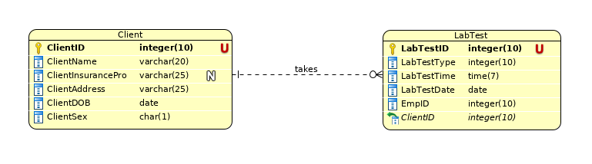

- Revise the ERD from problem 1 with more details about test types. A test type includes a unique test type identifier, a test type name, a test type cost, and a test type code. A lab test administered to a client is associated with one test type. A test type can be administered to multiple clients. A test type can exist in the database without ever being administered.
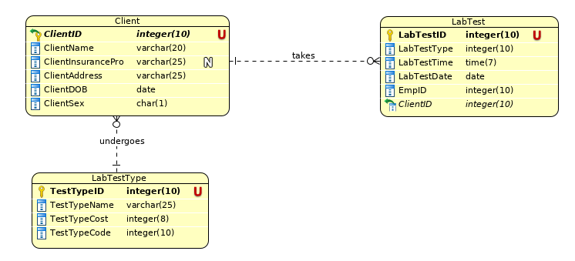

- Revise the ERD from problem 2 with test type items. A test type item includes a unique test item identifier, a test item name, test item unit of measure, and a test item description. A test type includes one or more test items. A test item can be part of one or more test types. Do not use an M-N relationship.
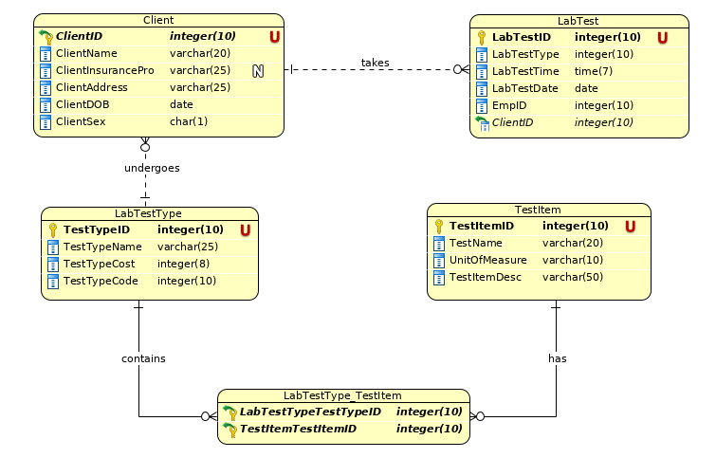
u

